HHS WHRSC HR BizFlow System

Deployment

Document Control Information

Document Information

|  |  |
| --- | --- |
| Document Identification | HHS DEV QA July 20 WHRSC BizFlow HR System Deployment.docx |
| Document Name | Deployment |
| Project Name | HHS WHRSC BizFlow HR System |
| Client | WHRSC |
| Document Author | Yung Oh |
| Document Version | 1.0.0 |
| Document Status | Draft |
| Date Released |  |
| Business Specifications Requirement Document ID |  |
| Functional Specification ID |  |

Document Edit History

| Version | Date | Additions/Modifications | Prepared/Revised by |
| --- | --- | --- | --- |
| 1.0.1 | 19-July-2018 |  | Youngjin Oh |

Document Review/Approval History

| Date | Name | Organization/Title | Comments |
| --- | --- | --- | --- |
|  |  |  |  |
|  |  |  |  |
|  |  |  |  |
|  |  |  |  |
|  |  |  |  |

Distribution of Final Document

The following people are designated recipients of the final version of this document:

| Name | Organization/Title |
| --- | --- |
| <Name> | <Organization/Title> |
|  |  |

Table of Contents

1. Introduction 4

2. Required system version information 5

3. Development directory structure 6

3.1 database Directory contents 6

3.2 deploy directory contents 6

3.3 process directory contents 7

3.4 report directory contents 7

3.5 wm-project directory contents 7

3.6 wm-runtime directory contents 8

4. Methods of deployment file delivery 9

4.1 Development repository in GitHub 9

5. Deployment Steps 10

5.1 Database Deployment 10

5.1.1 Create database schema and user 10

5.1.2 Grant permission required for program object creation 10

5.1.3 Create objects for business data model 10

5.1.4 Grant permission to the business data mode objects created 11

5.1.5 Create core table and program objects 11

5.1.6 Grant permission to the core table and program objects created 11

5.1.7 Insert seed data (a.k.a. day-zero data) 11

5.2 BIX deployment 12

5.3 Report Deployment 22

5.4 UI Module Packaging 24

5.4.1 Pre-requisite on DEV Server 24

5.4.2 Packaging Steps 24

5.5 Web Application (UI Module) Deployment 25

5.6 Configuration 27

BizFlow Server Configuration files. 27

5.6.1 server.ini Configuration 27

5.6.2 Web Server Configuration files. 27

5.6.3 BizFlow Web Portal Configuration 30

5.6.4 BizFlow Global Variable Configuration 31

5.6.5 Internet Explore Configuration 32

6. Event Response Adaptor (ERA) 36

# Introduction

This document describes how to deploy the HHS WHRSC BizFlow HR system. It is assumed that there are 2 environments, DEV,QA and PROD. The instruction for deployment for each environment will be the same except for configuration. Configuration should be done specifically for each target environment.

# Required system version information

1. BizFlow: BizFlow Server version 12.4
2. Database: Oracle 12c
3. Web Server: Tomcat 7
4. Java: JDK 7

# Development directory structure

The following directory capture will be delivered as part of the release of the system.

WHRSC-BizFlow/database/

WHRSC-BizFlow/deploy/

WHRSC-BizFlow/process/

WHRSC-BizFlow/report/

WHRSC-BizFlow/ui/

WHRSC-BizFlow/ui/wm-project/

WHRSC-BizFlow/webapps/bizflow

## 3.1 database Directory contents

This directory contains database scripts (.sql files) to create database schema, users, and other objects, which includes the definition for tables, stored procedures, functions, triggers, sequence.

The DBA will execute the database scripts in Oracle database client (e.g. SQLPlus, SQL Developer, etc.) in the designated order (as part of the filename) so that the database for the system can be created.

Script file example:

WHRSC_HR_DB_01_create_schema.sql

WHRSC_HR_DB_02_grant_permission_bizflow.sql

WHRSC_HR_DB_03_create_model_objects.sql

WHRSC_HR_DB_04_grant_permission_model.sql

WHRSC_HR_DB_05_create_core_table.sql

WHRSC_HR_DB_06_create_core_program.sql

WHRSC_HR_DB_07_grant_permission_core.sql

WHRSC_HR_DB_08_1_insert_seed_data_OCCUPATIONAL_SERIES.sql

WHRSC_HR_DB_08_2_insert_seed_data_TYPE_VALUES.sql

WHRSC_HR_DB_08_3_insert_seed_data_RDR_APPROVAL.sql

## 3.2 deploy directory contents

This directory contains script to capture web runtime files, deployment scripts, etc.

It is assumed Apache ANT is available to run the runtime capture script (build.xml).

The deployment script for UI module is for Linux server environment where shell program is available.

For example:

build.xml

## 3.3 process directory contents

This directory contains BizFlow Import Export file (.bix files), which contains the process definition, the application definition, user group definition, BizCove and menu design.

The system administrator will use BizFlow Process Studio in order to import the .bix file to a designated BizFlow Server environment.

BIX file example:

whrsc.bix

## 3.4 report directory contents

This directory contains BizFlow Advanced Reporting Export file (.zip file), which contains data source, report domain definition, input control definition, and report definition.

The system administrator will use command line tool to import the report export (.zip) file to the designated BizFlow Advanced Reporting Server environment.

Report export file example:

whrscreport.zip

## 3.5 wm-project directory contents

This directory contains WebMaker project export files (.zip files), which is form design source code.

The system administrator will use WebMaker Design Studio in order to import each of the project export files, generate runtime files, then, deploy them to the designated environments. As an alternative, wm-runtime directory contains the same generated web application files, which is ready to be deployed without going through WebMaker Design Studio.

WebMaker project export file example:

determine_staffing_export.zip

rdr_programapproval_export.zip

rdr_uploadassignment_export.zip

whrsc_appointment_appointment_export.zip

whrsc_appointment_approval_export.zip

whrsc_appointment_finalprocessing_export.zip

whrsc_appointment_main_export.zip

whrsc_appointment_orientation_export.zip

whrsc_appointment_payinformation_export.zip

whrsc_appointment_transaction_export.zip

whrsc_AUT_export.zip

whrsc_common_export.zip

whrsc_recruitment_applicant_export.zip

whrsc_recruitment_certificate_export.zip

whrsc_recruitment_main_export.zip

whrsc_recruitment_prerecruitment_export.zip

whrsc_recruitment_transaction_export.zip

whrsc_recruitment_vacancy_export.zip

## 3.6 wm-runtime directory contents

This directory contains WebMaker runtime directories and files, which are generated from WebMaker Design Studio after importing respective project export files.

The system administrator will simply copy all of the runtime files to the designated web server (i.e. Tomcat) directory of the target environment. Then, the WebMaker application configuration files (morphyc.xml file), which should be tailored for the target environment will be copied to the designated directories.

/webapps/bizflowwebmaker/determinestaffing/

/webapps/bizflowwebmaker/rdr_programapproval/

/webapps/bizflowwebmaker/rdr_uploadassignment/

/webapps/bizflowwebmaker/whrsc_appointment/

/webapps/bizflowwebmaker/whrsc_AUT/

/webapps/bizflowwebmaker/whrsc_common/

/webapps/bizflowwebmaker/whrsc_recruitment/

...

/configuration/dev/tomcat/webapps/bizflowwebmaker/determinestaffing/doc/morphyc.xml

/configuration/dev/tomcat/webapps/bizflowwebmaker/rdr_programapproval/doc/morphyc.xml

/configuration/dev/tomcat/webapps/bizflowwebmaker/rdr_uploadassignment/doc/morphyc.xml

/configuration/dev/tomcat/webapps/bizflowwebmaker/whrsc_appointment/doc/morphyc.xml

/configuration/dev/tomcat/webapps/bizflowwebmaker/whrsc_AUT/doc/morphyc.xml

/configuration/dev/tomcat/webapps/bizflowwebmaker/whrsc_common/doc/morphyc.xml

/configuration/dev/tomcat/webapps/bizflowwebmaker/whrsc_recruitment/doc/morphyc.xml

...

The same set of configuration files for QA and PROD environments will be provided under the respective directories.

/configuration/qa/

/configuration/prod/

# Methods of deployment file delivery

The following methods of deployment file delivery may be considered.

* USB drive to HHS team
* Upload to a designated ftp/sftp site in HHS network by authorized Deloitte team
* Upload from HHS issued laptop by authorized Deloitte team
* Download from HHS GitHub site (https://github.com/HHS) by HHS personnel.

NOTE: The Confluence site will be discontinued as code repository in the near future. Therefore, it is strongly recommended to use GitHub going forward.

## 4.1 Development repository in GitHub

1. Log in to GitHub for HHS (https://github.com/HHS).
2. On the dashboard, select context dropdown to “HHS”.
3. On the Repositories pain, search for “BizFlow”, and select “HHS/WHRSC-BizFlow”.

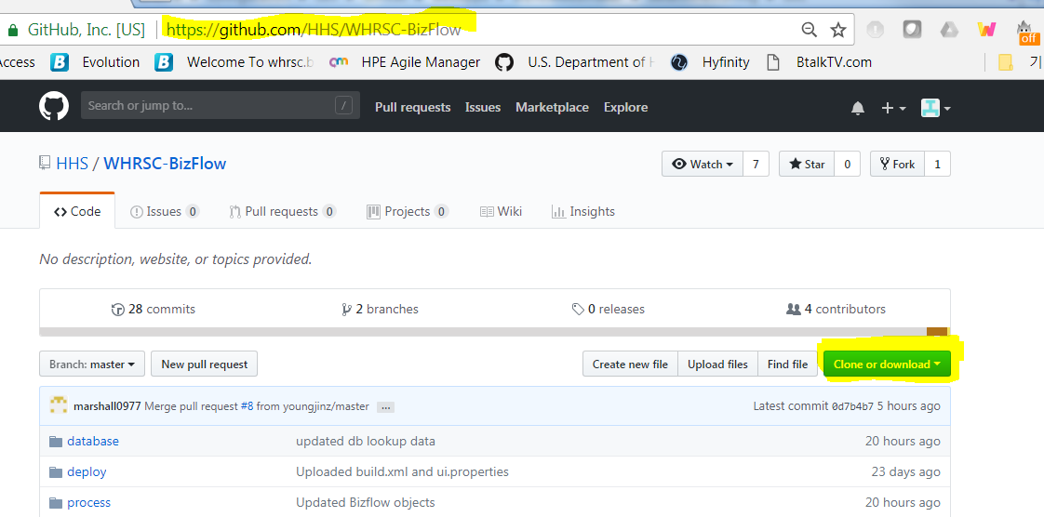

1. Verify the URL and repository name.
2. Click “Clone or download” button. If you intend to set up local git repository and continue to use it in the future, clone the repository using SSH or HTTPS option. If you want to download the entire repository for each build/deploy, select “Download ZIP” option.

# Deployment Steps

## 5.1 Database Deployment

A DBA should perform the following steps using Oracle database client.

### 5.1.1 Create and Alter tables

Using the HHS_WHRSC_HR user login, execute the following script.

WHRSC-BizFlow\database\Sprint 3 only\WHRSC_HR_DB_UPD_01_ddl_tables.sql

### 5.1.2 Grant permission to the business data mode objects created

Using the Oracle system user login, execute the following script.

WHRSC-BizFlow\database\Sprint 3 only\WHRSC_HR_DB_UPD_03_permission.sql

### 5.1.3 Delete seed data

Using the HHS_WHRSC_HR user login, execute the following script.

WHRSC-BizFlow\database\Sprint 3 only\WHRSC_HR_DB_UPD_04_dml.sql

## 5.2 BIX deployment

Import BizFlow Process definitions and BizCoves

Pre-requisite

* BizFlow Server is installed and BizFlow Server is running.
* BizFlow Process Studio (BPS) is installed.
* BizFlow user with “General Administrator” and “Designer” license is created for migration.

In this instruction, a user login “import_user” is assumed to be set up with the necessary permission. In order to verify the BizFlow user with proper permission, log in to BizFlow Portal site as a system administrator, and check the Authentication configuration.

1. Log in to BizFlow Portal as a system administrator.
2. Click “ADMINISTRATION” tab on the top right corner.
3. Click Authentication on the administration page.
4. Search the user login to verify and click on the login ID found to open User Details wizard.
5. Click License tab and Authority Group tab in the wizard to verify the license assignment and Authority Group assignment.

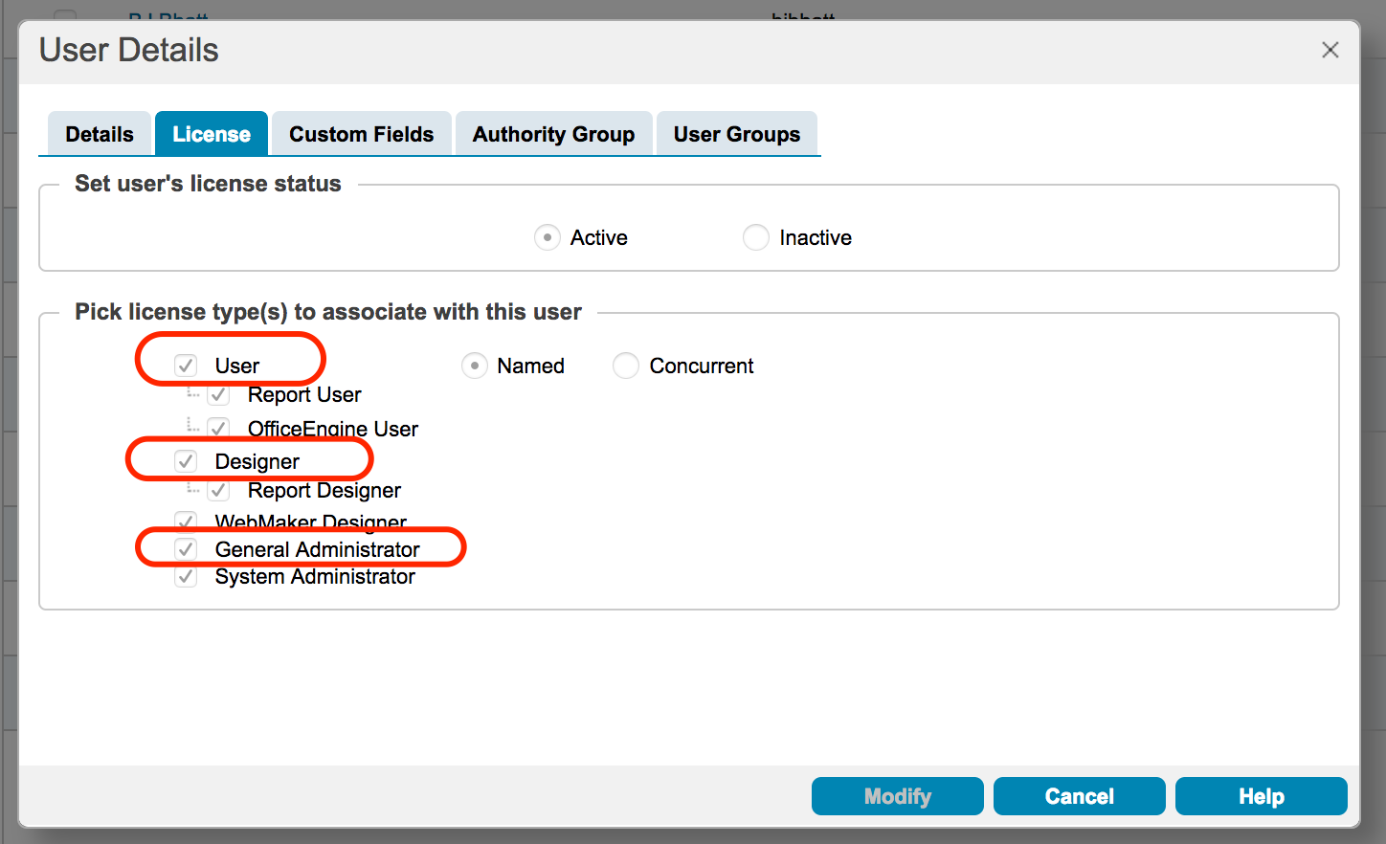

For Authority Group assignment option, it is recommended to use “Explicit”. Then, make sure explicitly select Designer and General Administrator Authority Group along with others.

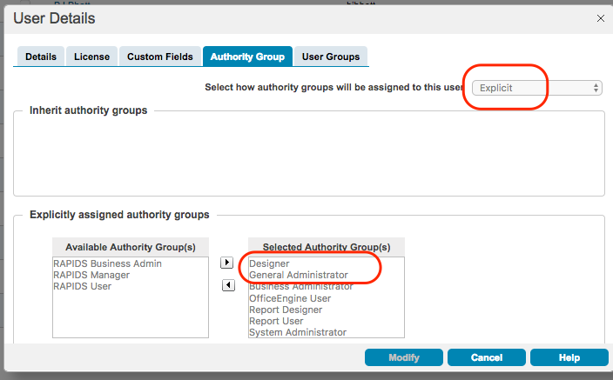

When all pre-requisite for BIX import are verified, begin the import steps.

1. Step1 – Register BizFlow server to BPS
   1. Launch BPS and click “BizFlow Server” icon.

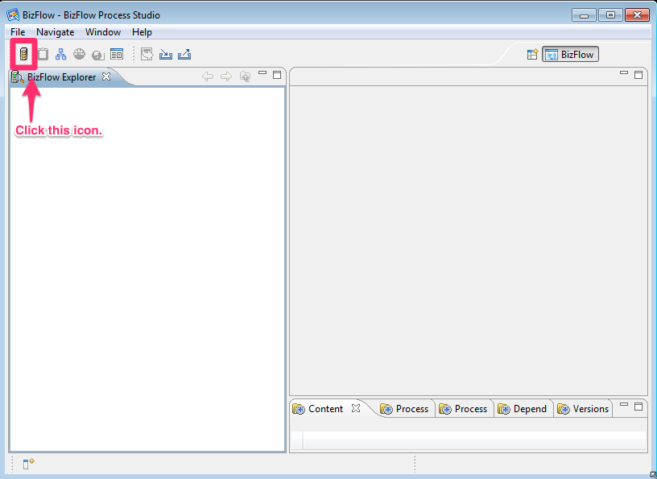

* 1. Provide Server information.

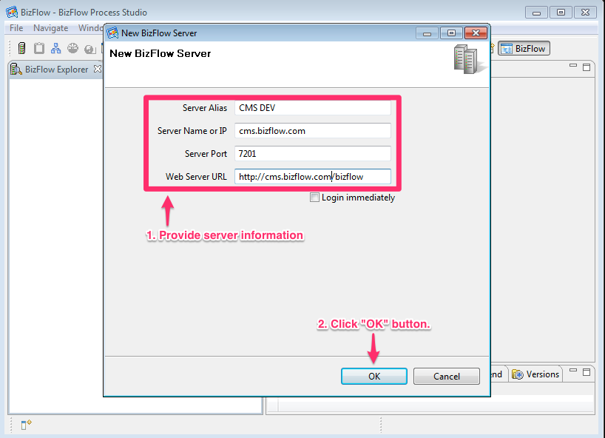

1. Step 2 - Log on to BizFlow Server.
2. This user needs to have “General Administrator” and “Designer” license.

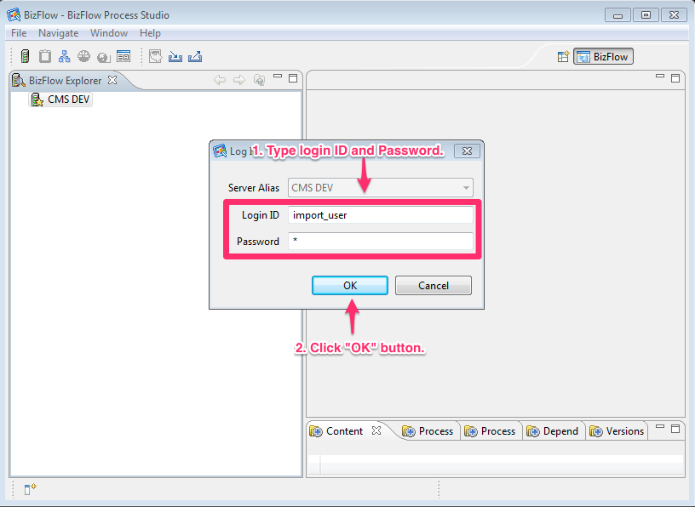

1. Step 3 - Click “Import” button.

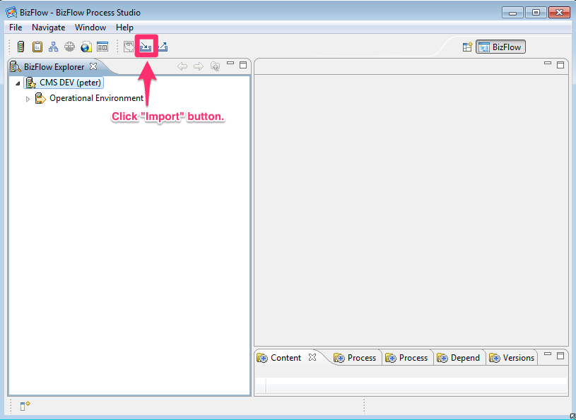

1. Step 4 - Select BizFlow BIX file.
2. Select proper server alias name in “Target Server” section.
3. Click “Browse” button and select “whrsc.bix” file.
4. Click “Next” button.

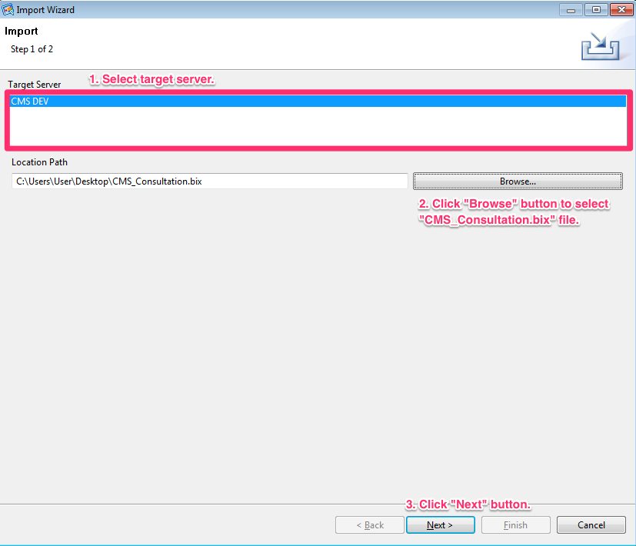

1. Step 5 - Click “+” icon to expand items and select “/Operational Environment/User Configuration/Authentication”.

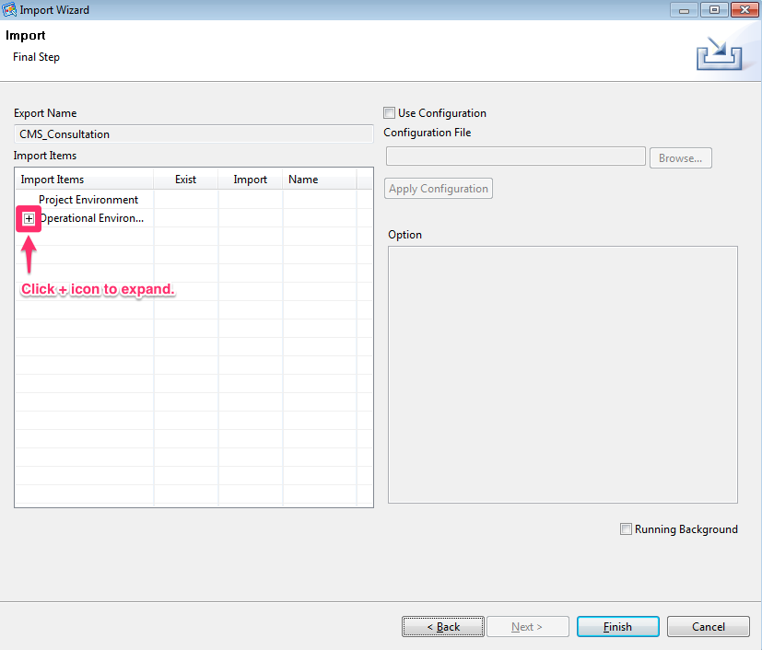

1. Step 6 - Uncheck “Create Users” option.
2. Import column should be set as “No”.

**Note**: The Create User option may be turned on in case user login accounts should be migrated, but in general, it should not be used. In the future deployment package, the test user entry may be excluded so that you may skip the Step 6.

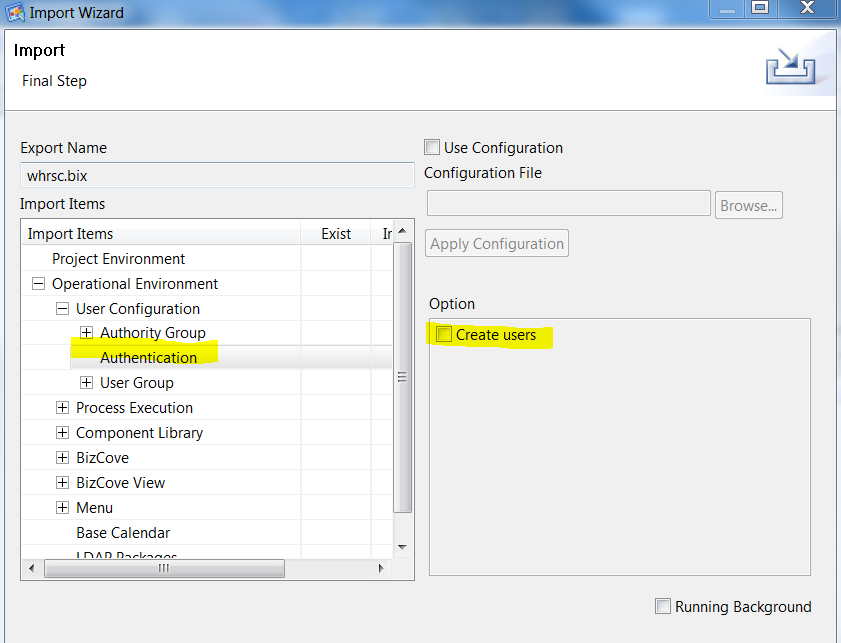

1. Step 7 - Uncheck “Link Users” option in “/Operational Environment/User Configuration/User Group”.

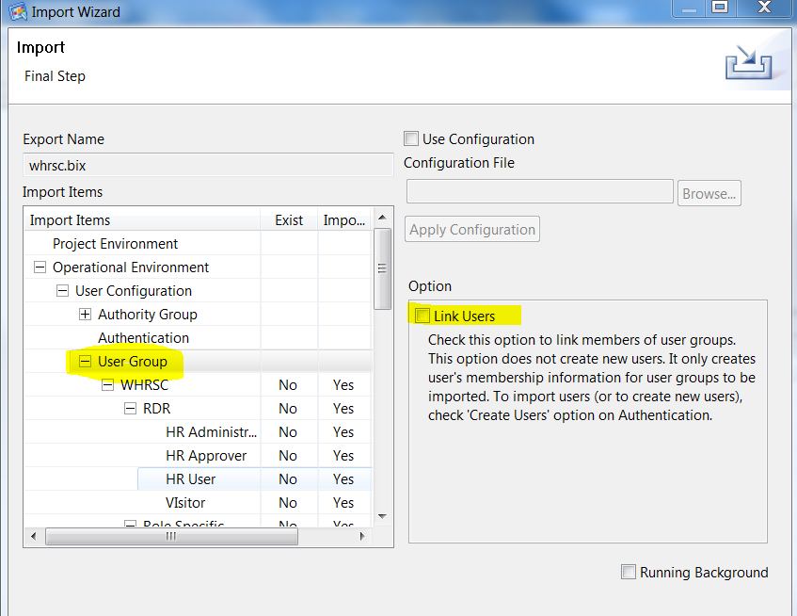

1. Step 8 - All user group under “/Operational Environment/User Configuration/User Group/WHRSC” should have “Yes” in “Import” column.

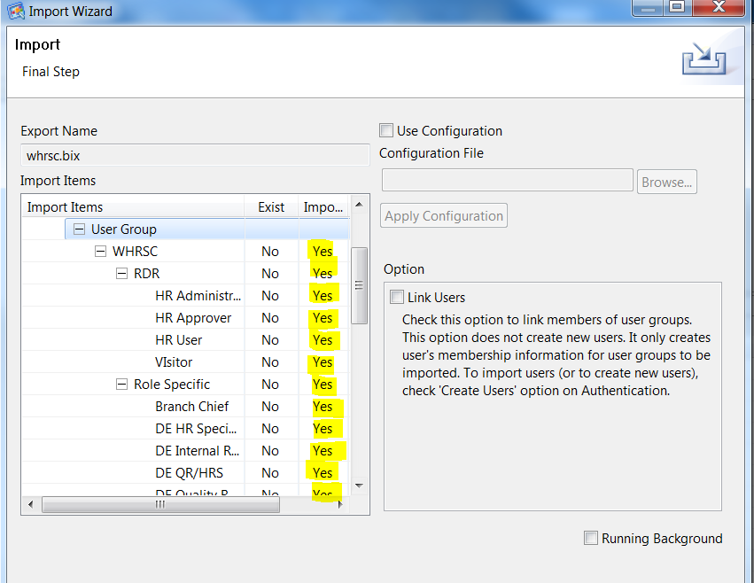

1. Step 9 - All Process Definitions under “/Operational Environment/Process Execution/Process Definition/Process Definitions/WHRSC” should have “Yes” in “Import” column.

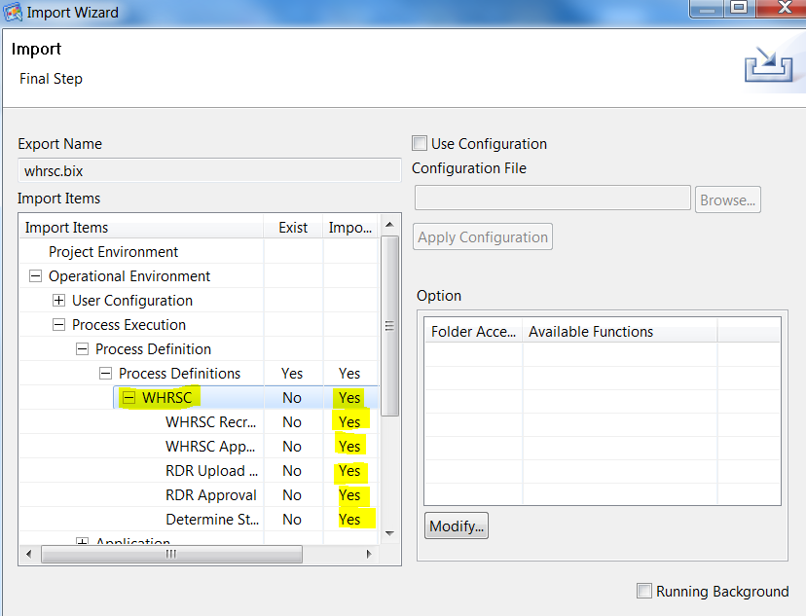

1. Step 10 - All Applications under “/Operational Environment/Application/Application/CMS” should have “Yes” in “Import” column.

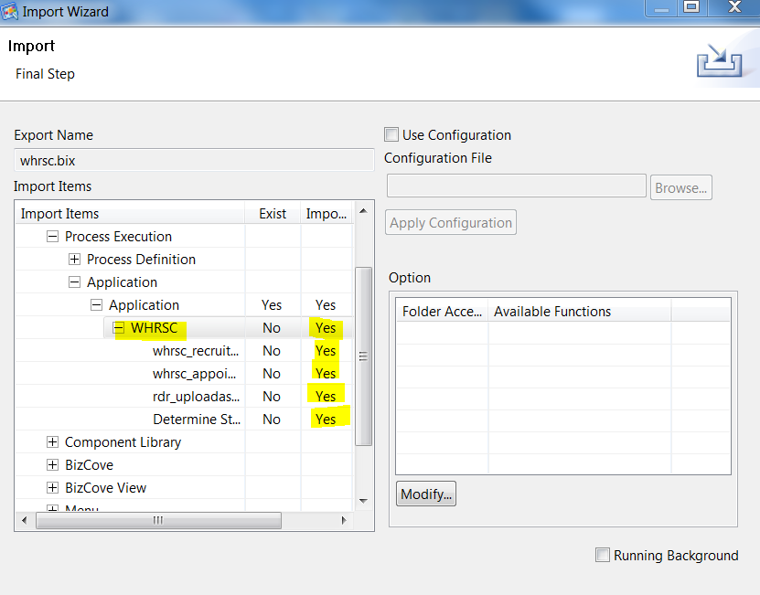

1. Step 11 – Set the value in “Import” column to “Yes” under “/Operational Environment/Component Library/Global Variable”.

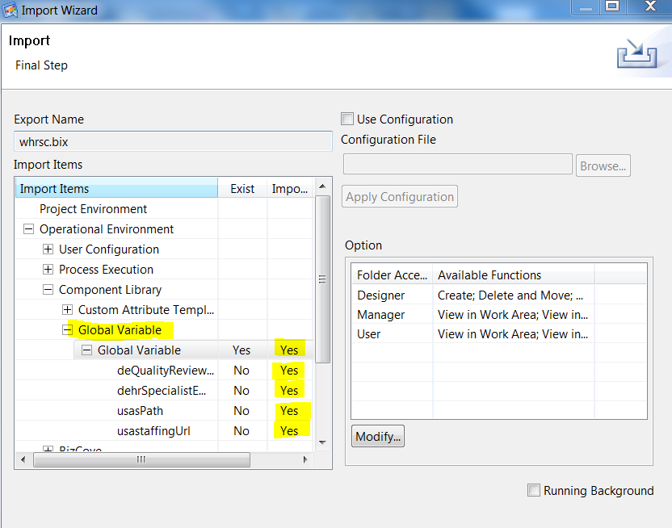

1. Step 12 - All BizCoves under “/Operational Environment/BizCove” should be set to “Yes” in Import column.

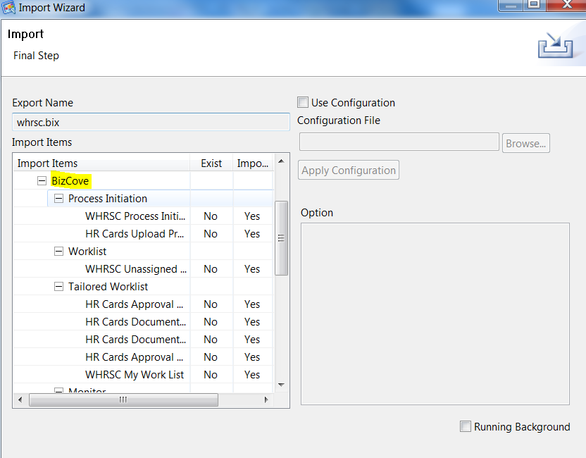

1. Step 13 - All BizCove View under “/Operational Environment/BizCove View” should have “Yes” in Import column.

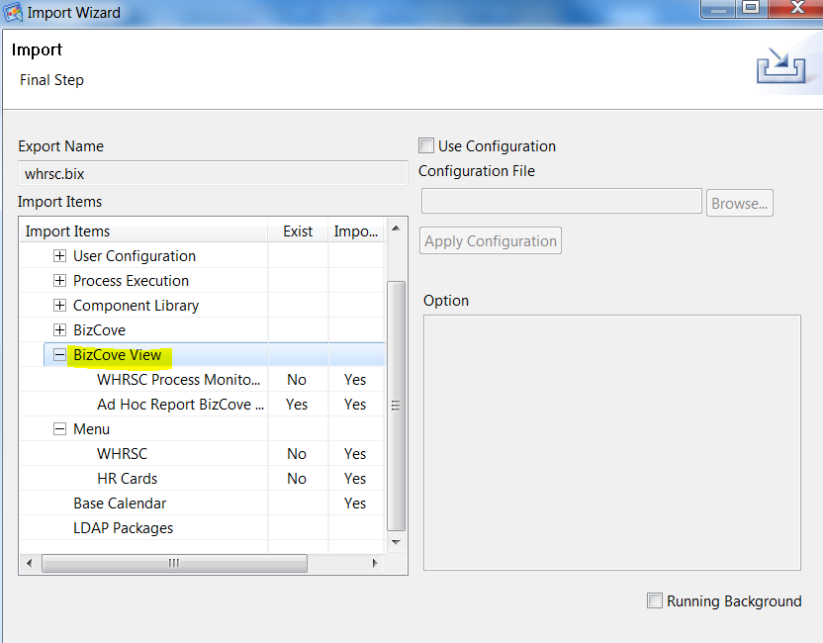

1. Step 14 - All Menu under “/Operational Environment/Menu” should have “Yes” in Import column.

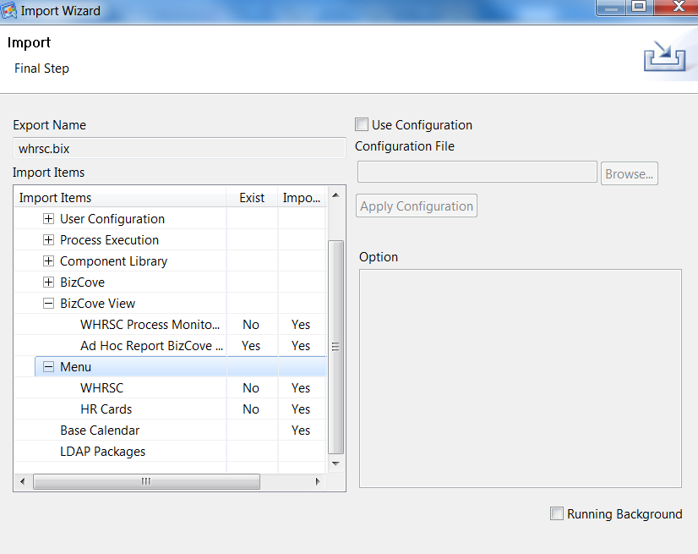

1. Step 15 - Click “Finish” button.

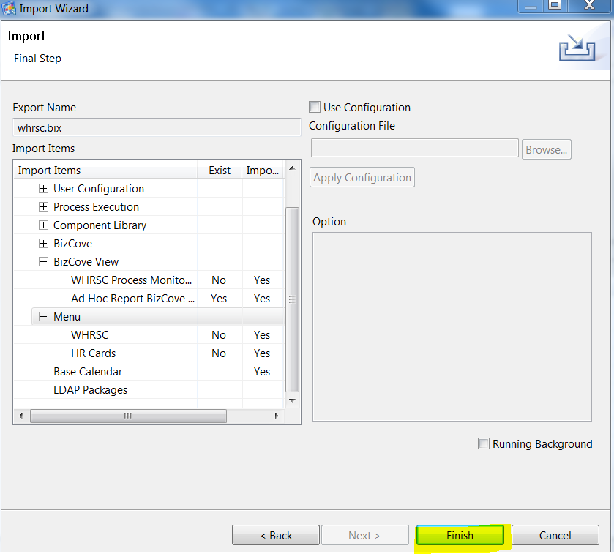

1. Step 16 - Click “OK” button and check log files.

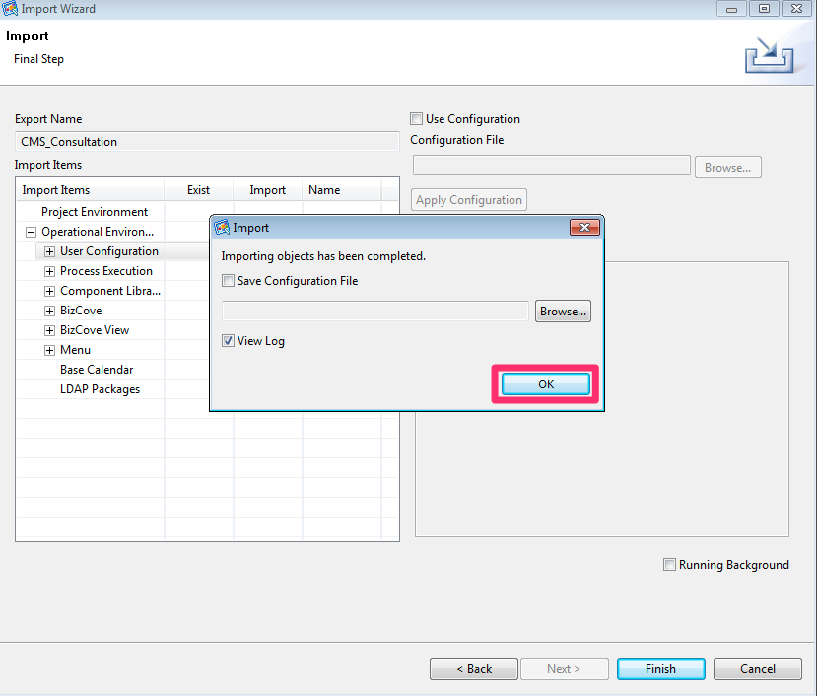

1. Repeat Step 1 through Step 16 per each environments.

## 5.4 UI Module Packaging

UI modules are captured from DEV environment's web application directory, using ANT build file.

The ANT build file will package the UI modules in a zip file. Especially for WebMaker runtime files, the script will capture configuration files separately per environment, which will be deployed to the target environment appropriately by the deployment script later on. The script also appends timestamp to the JavaScript and CSS file references in the web application files so that the web browser cache is forced to be refreshed at the first time loading after the new deployment.

### 5.4.1 Pre-requisite on DEV Server

* JDK/JRE 1.7
* Apache Ant 1.9.x
* Administrator (or sudo) access to DEV server machine
* UI modules are deployed and tested in DEV server, and ready for promotion to higher environments (e.g. QA and PROD)
  + WebMaker form runtime files
  + BizFlow solution files

### 5.4.2 Packaging Steps

1. Login to DEV server machine with an administrator (or sudo) account.
2. In the command line prompt, create a work directory where files will be generated, and change directory to it.

For example:

mkdir -p work/deploy

cd work/deploy

1. Copy UI packaging script to the deployment directory.

* From (source repository):

deploy/build.xml

* To (target environment):

*<DEV_server_dir>*/work/deploy/

1. Using a text editor, modify the following property value in the build.xml file for tomcat web application directory setting. Specify the full path to the tomcat directory.

<property name="**webserver.dir**" value="*full_path_to_tomcat_directory*" />

1. In the command line prompt, run ANT. The following will execute the default target, which will generate a zip file.

ant

1. Capture the generated zip file. The packaging script will create the intermediate directories and generate the UI runtime zip file with timestamp suffix.

For example:

*<DEV_server_dir>*/work/deploy/deployment/ui/runtime_*20180201_132525*.zip

## 5.5 Web Application (UI Module) Deployment

UI modules are deployed to the higher environments (e.g. QA, PROD) using shell scripts.

The deployment script will stop tomcat service, copy runtime files to tomcat web application directory, and start tomcat service.

1. Login to higher environment server machine with an administrator (or sudo) account.
2. In the command line prompt, create a work directory where the deployment package file will be placed, and change directory to it.

For example:

mkdir -p work/deploy/baseline/ui

cd work/deploy

1. Copy UI deployment script to the deployment directory.

* From (source repository):

deploy/deploy_ui_qa.sh

* To (target environment):

<DEV_server_dir>/work/deploy/

1. Using a text editor, modify the following property value in the deploy_ui_qa.sh for tomcat web application directory setting. Specify the full path to the tomcat directory.

**DIR_DEPLOY**=*<full_path_to_deploy_baseline_directory_above>*

**DIR_TOMCAT**=*<full_path_to_tomcat_directory>*

1. In the command line prompt, make the UI deployment script mode executable.

For example:

chomod 744 deploy_ui_qa.sh

1. Copy UI deployment package file to the UI deployment directory.

For example:

* From (source repository):

runtime_20180201_132525.zip

* To (target environment):

*<DEV_server_dir>*/work/deploy/baseline/ui

1. In the command line prompt, extract the UI runtime zip file. If there is previous extract of runtime files, remove it before fresh extract.

For example:

cd baseline/ui

rm -rf runtime

unzip runtime_*20180201_132525*.zip

1. Copy bizflow directory from runtime\webapps to runtime\configuration\dev or QA\tomcat\webapps.
2. In the command line prompt, change directory back to the deployment directory, and run the deployment script.

For example:

cd <DEV_server_dir>/work/deploy

./deploy_ui_qa.sh -nodebug

Note: The deployment script has "-nodebug" option for real deployment action. If you run the script without the option, it will try to test directory setting without actually deploying any file. This is a precautionary measure to prevent accidental overwriting of the target application files. In order to run the deployment script in "DEBUG" mode, i.e. without "-nodebug" option, a dummy script should be placed in the deployment directory. Make sure the dummy script mode is executable.

For example:

* From (source repository):

deploy/script1.sh

* To (target environment):

*<DEV_server_dir>*/work/deploy/

cd <DEV_server_dir>/work/deploy

chomod 744 script1.sh

./deploy_ui_qa.sh

About Deloitte

Deloitte provides audit, tax, consulting, and financial advisory services to public and private clients spanning multiple industries. With a globally connected network of member firms in 140 countries, Deloitte brings world-class capabilities and deep local expertise to help clients succeed wherever they operate. Deloitte's 165,000 professionals are committed to becoming the standard of excellence.

Deloitte's professionals are unified by a collaborative culture that fosters integrity, outstanding value to markets and clients, commitment to each other, and strength from cultural diversity. They enjoy an environment of continuous learning, challenging experiences, and enriching career opportunities. Deloitte's professionals are dedicated to strengthening corporate responsibility, building public trust, and making a positive impact in their communities.

Deloitte refers to one or more of Deloitte Touche Tohmatsu, a Swiss Verein, and its network of member firms, each of which is a legally separate and independent entity. Please see www.deloitte.com/about for a detailed description of the legal structure of Deloitte Touche Tohmatsu and its member firms. Please see <http://www.deloitte.com/us/about> for a detailed description of the legal structure of Deloitte LLP and its subsidiaries.

Internal Usage Statement

This publication is for internal distribution and use only among personnel of Deloitte Touche Tohmatsu, its member firms, and its and their affiliates. Deloitte Touche Tohmatsu, its member firms, and its and their affiliates shall not be responsible for any loss whatsoever sustained by any person who relies on this publication.

Copyright © 2012 Deloitte Development LLC. All rights reserved.

Member of Deloitte Touche Tohmatsu